MODULE 4 – INTRODUCTION TO DBMS

LAB EXERCISES

4. Main SQL Commands and Sub – Commands – DDL
Lab 1.
Create a table authors with the following columns – author_id, first_name, last_name, and country. Set author_id as the primary key.
Ans.
1. CREATE TABLE authors (author_id int PRIMARY KEY, first_name varchar(255), last_name varchar(255), country varchar(255));
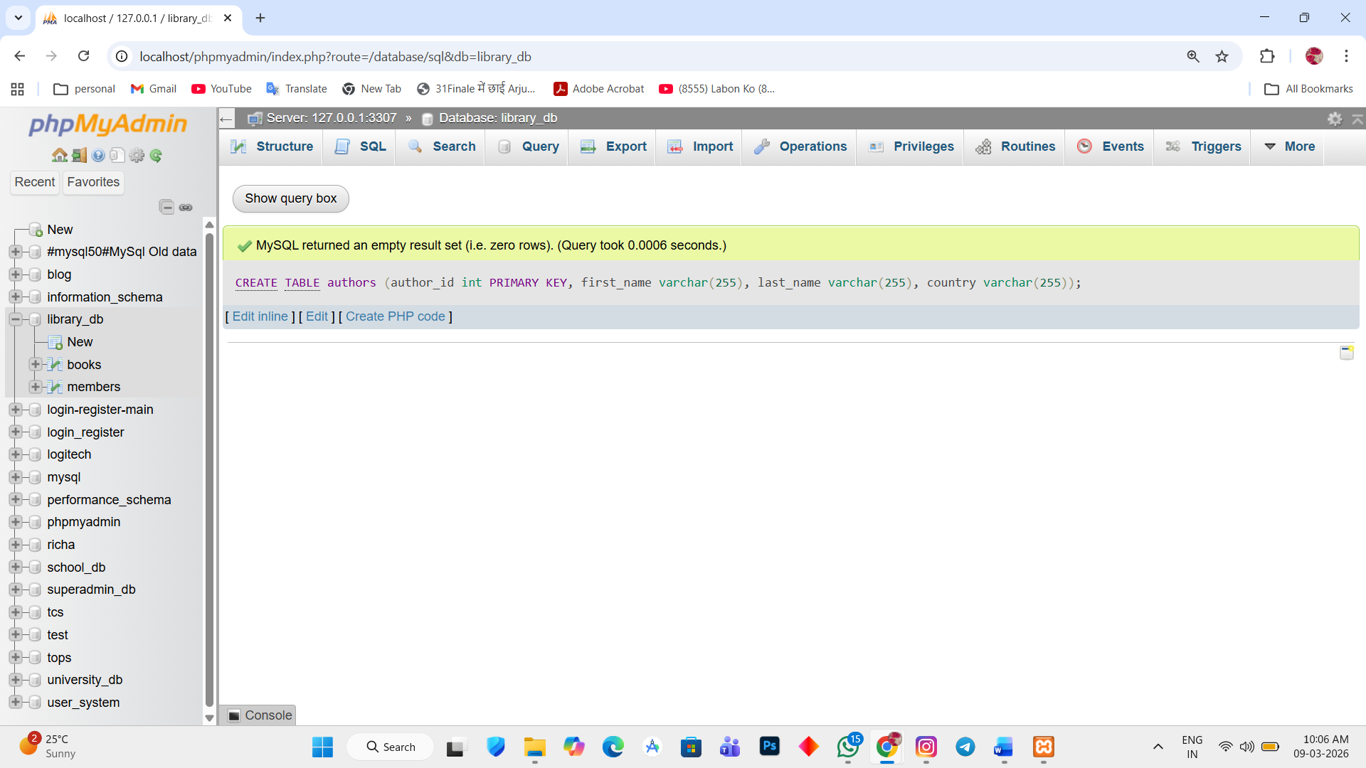

Lab 2.
Create a table publishers with columns – publisher_id, publisher_name, contact_number and address. Set publish_id as the primary key and contact_number as unique.
Ans.
1. CREATE TABLE publishers(publisher_id int PRIMARY KEY, publisher_name varchar(255), contact_number varchar(255) UNIQUE, address varchar(255));
